Lab - Creating a Virtual Install of Server 2012r2 Using VirtualBox

Overview

In this lab, students will create a virtual install of Server 2012 r2 with GUI using VirtualBox. This lab is designed to run on a MAC, Windows 7 64 bit, Windows 8/8.1 64 bit or Windows 10. The latest version of VirtualBox Player was used in confirming this lab as working.

The student should read the lab in its entirety before beginning the install.

System requirements for creating a virtual install of Server 2012 R2 using VirtualBox.

Windows Server 2012 r2 is available as either 32 or 64-bit operating system. This lab is built using a 64-bit hardware system, but the procedure for a 32-bit system is the same.

You can get a free copy of VirtualBox by using this link [Download VirtualBox](https://www.virtualbox.org/wiki/Downloads).

Begin the Lab!

Once you’ve downloaded VirtualBox, you can browse to the saved download location and run the installer. In this lab, I demonstrate installing VirtualBox, Version 5.2.6 but regardless of the version, the installation wizard remains intuitive.

On the opening screen, click next.

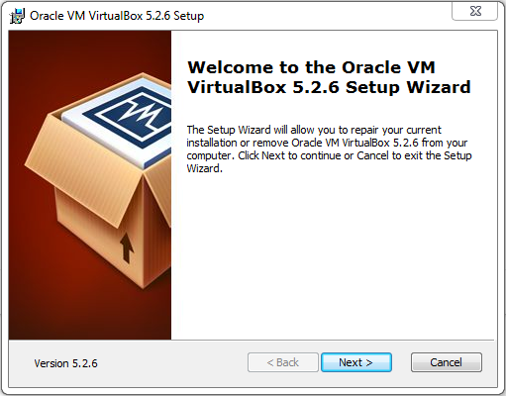

On the next screen, accept the defaults and click next.

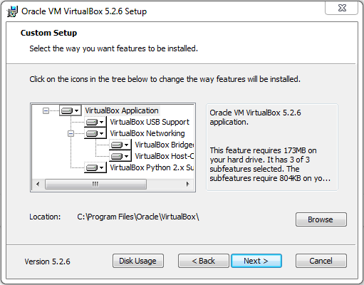

On the next screen, accept the defaults and click next.

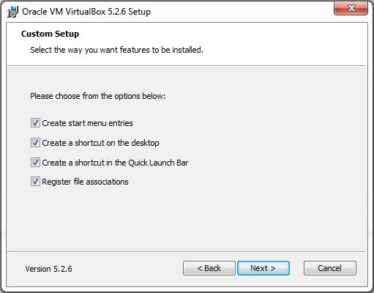

On the next screen, accept the warning and click Yes.

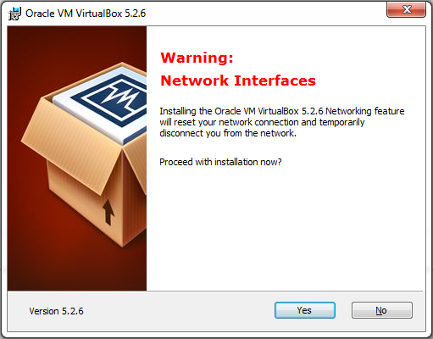

On the Ready to Install screen, click the install button.

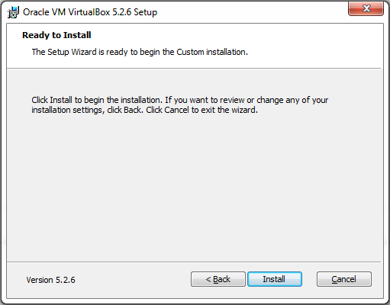

The installation begins.

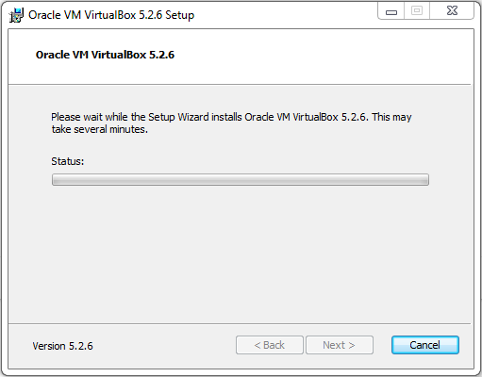

On the finish screen, click the finish button and if prompted, restart you host machine.

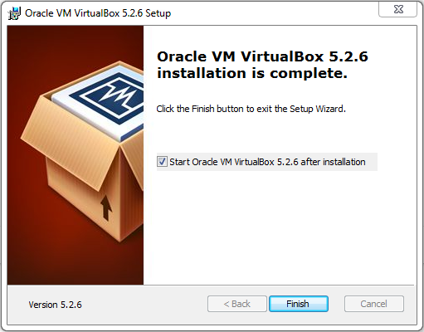

Installing Server 2012 r2 with GUI

In this next part of the lab, we begin the process of creating a virtual machine of Server 2012 r2.

We will first need to download an ISO image of Server 2012 r2 Standard Edition and save it to a location on our machine.

Download the ISO

Use this [direct link](https://www.dropbox.com/s/bzvi2ujt7uhufpd/9600.17050.WINBLUE_REFRESH.140317-1640_X64FRE_SERVER_EVAL_EN-US-IR3_SSS_X64FREE_EN-US_DV9.ISO?dl=0) to download the ISO file from the instructors DropBox account.

Download direct from Microsoft: [Server 2012 r2 ISO image](https://www.microsoft.com/en-us/evalcenter/evaluate-windows-server-2012-r2)

Once you have completed the download of the ISO image for Server 2012 r2 standard, open VirtualBox and begin creating a virtual install of Server 2012 r2.

To begin the 2012 r2 creation process, open VirtualBox and from the upper left corner, click on the New button.

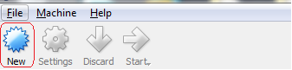

This launched the Create Virtual Machine Wizard.

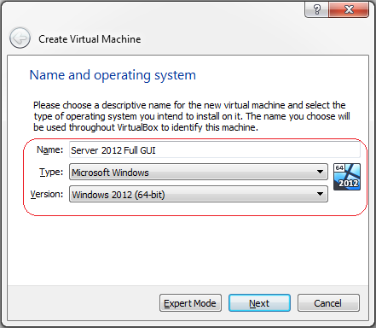

On the next window, accept the default of 2014 MB of RAM. Click next.

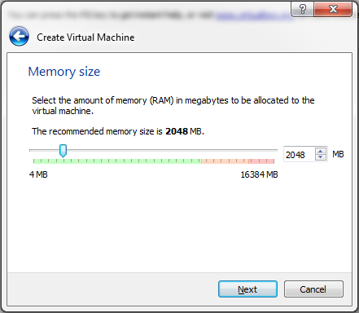

On the next screen, accept the default to create a virtual hard disk now. Click create.

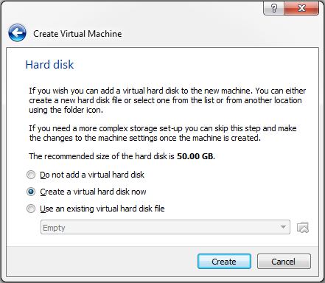

Accept the default for the hard disk type as VDI. Click next.

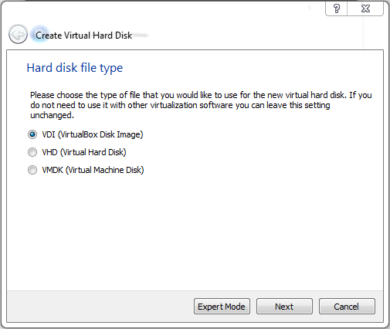

On the next screen, accept the default for the storage on the physical hard disk to be dynamically allocated.

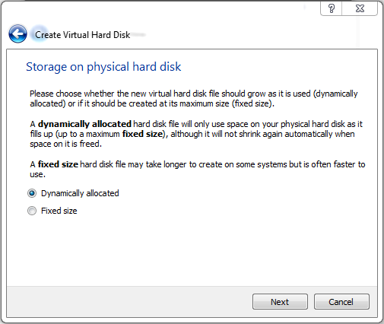

On the next screen, accept the default for the file location and size of 50 GB. Click create.

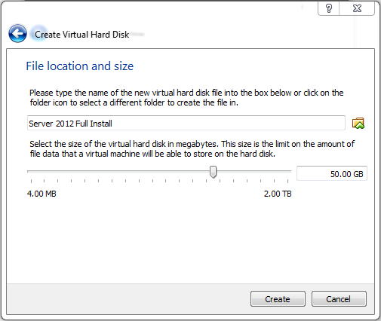

From the left window pane, ensure your disk for Server 2012 Full Install is highlighted and from the grey taskbar, click on the start arrow.

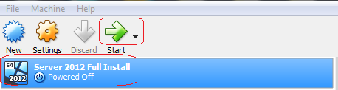

From the select Start-up Disk screen, click on the folder browse button and browse to the download location for your ISO image of Server 2012 r2. Double-click the ISO image and click the green Start arrow.

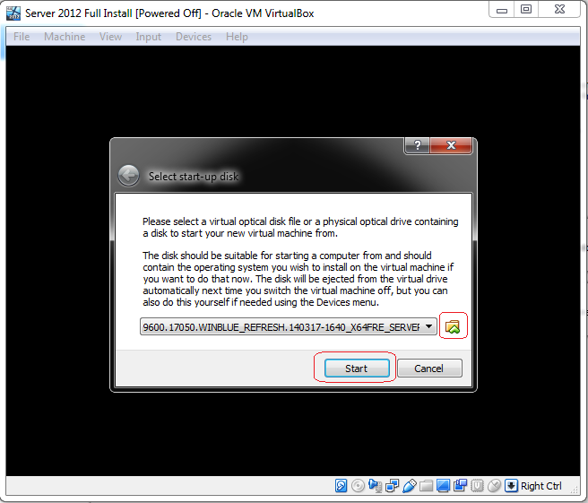

Step 9: VirtualBox begins the install.

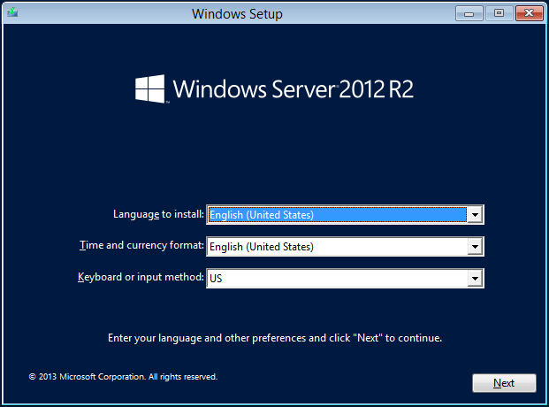

15. Click on Next to start the Windows Server 2012 R2 installation.

Click on Install now

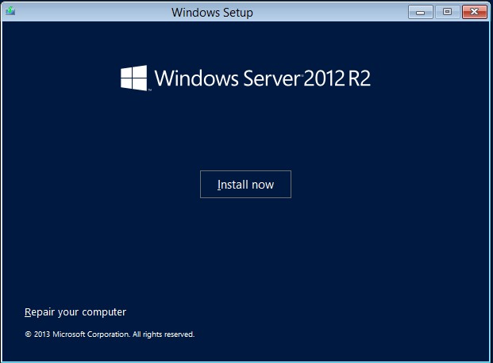

16. Select the operating system that you wish to install. Regardless if you install the Server 2012 R2 Datacenter or the 2012 R2 Standard version, you want the installing package that includes the GUI. Otherwise, you end up with just the Server 2012 Core and no GUI.

Datacenter can handle more RAM and CPU options, but they are identical operating systems. Students may use either for their labs.

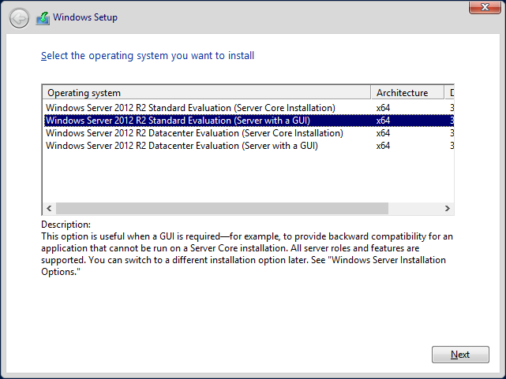

17. Accept the license agreement.

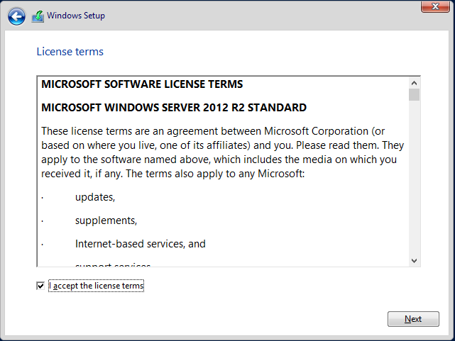

18. Select Custom Install Windows only (advanced).

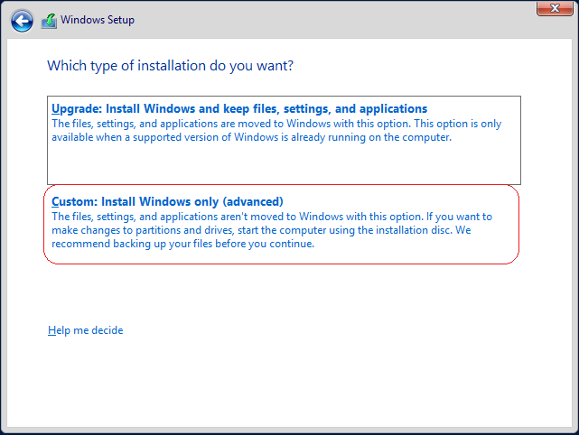

19. Nothing to do here but click Next.

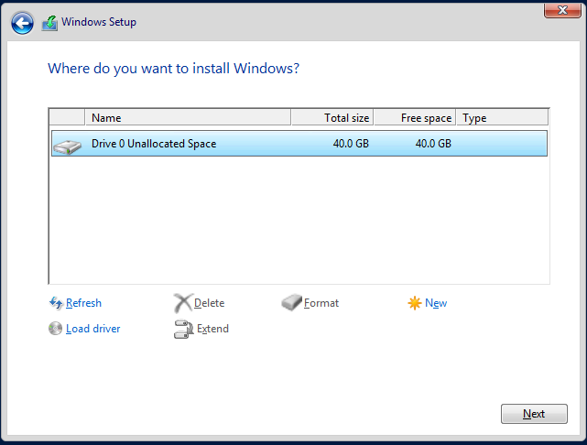

Server 2012 R2 beings the file copy process. Take a break while the installation finishes.

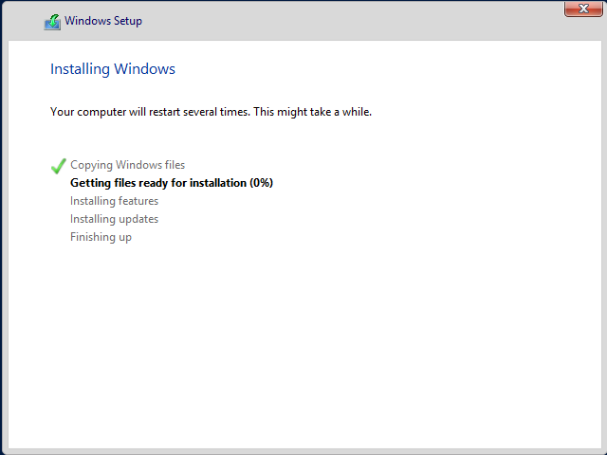

Windows will reboot. Be patient!

Before Server 2012 will allow you to log in, you must configure the password for the administrator account. Do try and remember your password. If you forget it, you will need to remove the machine and files from the VirtualBox Player Management Console and begin anew.

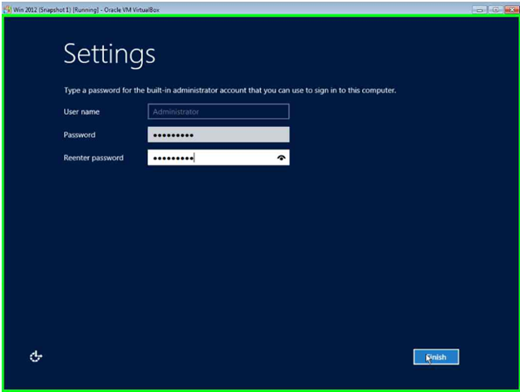

21. Click Finish. Welcome to Windows Server 2012 R2!

To login to Server 2012 R2, from the grey taskbar of VirtualBox, click on the Input option and select. Insert Ctrl+Alt+ Del from the context menu.

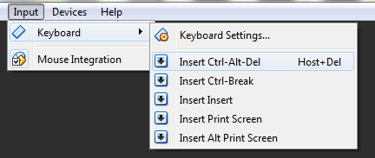

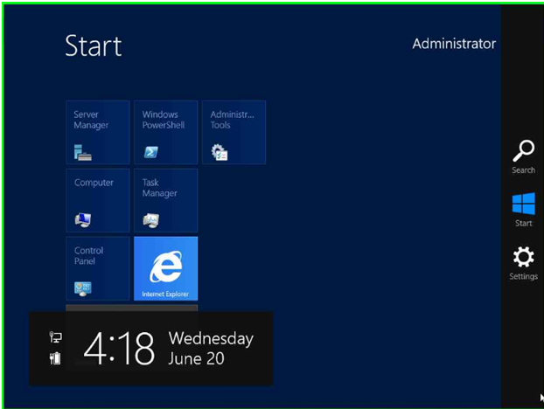

Prevent Windows from logging you off

After 10 minutes of inactivity Windows will log off. To prevent this from happening, we can set the turn off display option to never.

Click on the start button. Find the tile marked Control Panel.

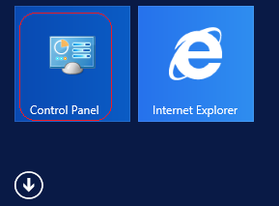

Change the category to Large icons.

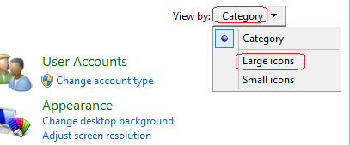

On the next screen, click on Power Options.



From the Choose or Customize a Power Plan screen, click on Change Plan Settings

Caveats for the preferred plan that is in use.

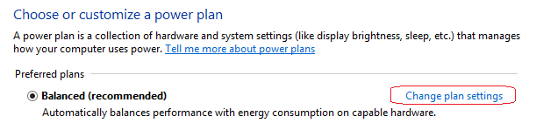

On the next page, pull down the window Turn off the display and select never.

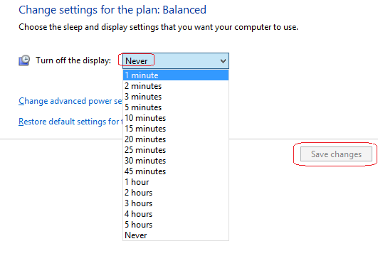

Power off or restart Server 2012

To Power off Server 2012, do so gracefully by using the shutdown button located at the top right. To access the power button, click on the start button and look to the upper right corner of the Start screen.

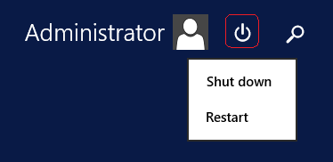

Caveat

Word of warning! Do not enable automatic updates for this server! Doing so will take days, use up plenty of bandwidth and will fill up your 60 GB partition in little to no time at all.

If the partition fills up, you will need to expand it or blow out the virtual machine and start over.

End of the Lab!